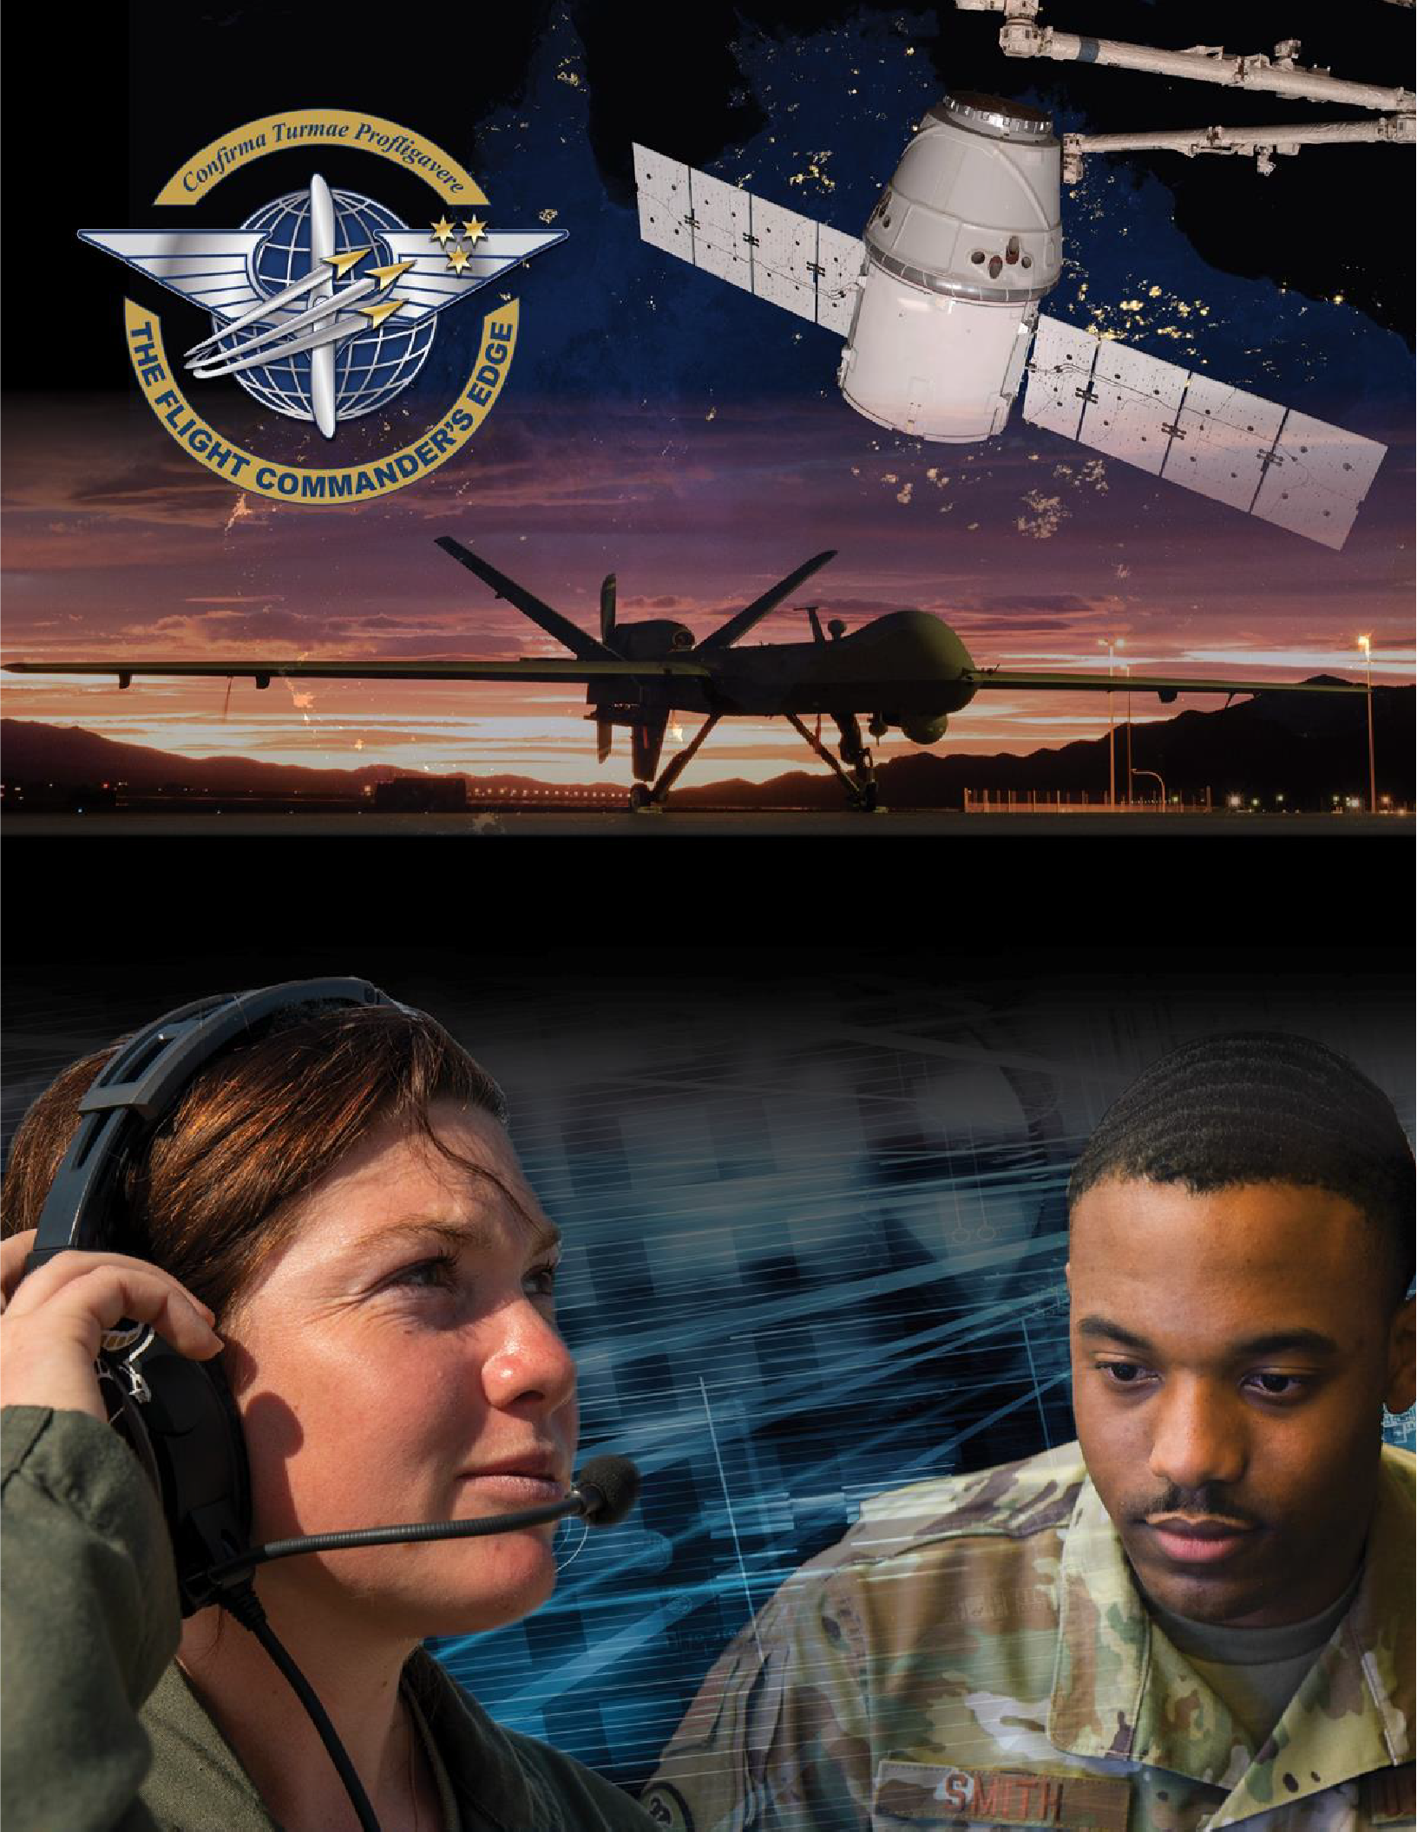

Lesson Plan

Mission Command in Leadership

#### 8 April 2025

## Table of Contents

About the Lesson 3

Before the Lesson 4

Presenting the Lesson 5

Appendix: Required Materials and Handouts 13

## How to Use this Lesson Plan

This lesson plan is divided into three key sections and an appendix containing supporting material.

The **About the Lesson** section outlines the lesson and identifies requirements for its effective use. Course Directors should use this section to (a) understand the purpose and context of the lesson, (b) learn about lesson pre-requisites, and (c) guide the selection of facilitators.

The **Before the Lesson** section provides details on the preparation required for this lesson, including participant prerequisites (if any), recommended facilitator pre-course readings, and guidance on how to prepare the classroom.

The **Presenting the Lesson** section contains the actual lesson plan. It provides the recommended outline, discussion, and slide prompts along with actual *questions* and *recommended language* for the facilitator to use in the classroom.

The **Appendix** includes any required in-class handouts or exercise material.

For more information on how lessons are structured, or how to use them in the course, see the

###### Course Director’s Handbook or Facilitator’s Resources.

## Contact Us

Email: [flightcommandersedge@us.af.mil](mailto:flightcommandersedge@us.af.mil)

Website: <https://www.airuniversity.af.edu/GCPME/Flight-Commanders-Edge/>

# About the Lesson

## Mission Command in Leadership

## Overview

This lesson examines how the Department of Defense concept of mission command (MC) can be used to ensure mission accomplishment while promoting flexibility. The lesson begins by examining how leaders motivate subordinates to get the job done while preserving flexibility.

**This discussion promotes self-discovery of the art of command through the principles of mission command.** The lesson ends with an exercise which helps the participant identify tips for implementing mission command behaviors at the flight level.

## Objectives

By the end of this lesson, participants will be able to:

1. Explore approaches for ensuring mission accomplishment while retaining flexibility.
2. Describe the principles of mission command.
3. Identify approaches to effectively use mission command at the flight level.

## Recommended Prerequisites

* None

## Recommended Time

* 50 minutes

## Recommended Facilitator Qualifications

This lesson is designed for a facilitator with the following minimum qualifications:

1. Subject matter knowledge
2. Command-level experience

Subject matter knowledge can be developed using the information presented in **Preparing the Facilitator** section of this document.

# Before the Lesson

## Preparing the Participant

* None. There is no pre-work for this lesson.

## Preparing the Facilitator

All required materials and participant preparation, plus:

* Read Army Doctrine Publication 6-0, [*Mission Command*](https://irp.fas.org/doddir/army/adp6_0.pdf) (2019). Pages 13-14; 15-19.
* Review the Joint Staff J7 [Insights and Best Practices Focus Paper on “Mission](https://www.jcs.mil/Portals/36/Documents/Doctrine/fp/missioncommand_fp_2nd_ed.pdf?ver=2020-01-13-083451-207&%3A~%3Atext=Mission%20command%20is%20the%20conduct%2Cinitiative%2C%20judgment%2C%20and%20creativity) [Command](https://www.jcs.mil/Portals/36/Documents/Doctrine/fp/missioncommand_fp_2nd_ed.pdf?ver=2020-01-13-083451-207&%3A~%3Atext=Mission%20command%20is%20the%20conduct%2Cinitiative%2C%20judgment%2C%20and%20creativity).”

(Optional) Additional deep-dive preparation materials are available on *The Flight Commander’s Edge* website.

## Preparing the Classroom

Ensure the classroom provides/is provisioned with:

* Adequate classroom space for separate small group discussions.
* Six white boards or easels with butcher block paper.
* Computer and projector (internet connectivity not required).

## Preparing Required Materials

Prepare one copy of each handout below for each participant. Do not distribute handouts before the class.

* Global College of PME, *The Principles of Mission Command Worksheet*
* Global College of PME, *Mission Command in Leadership Self-Assessment Worksheet*

Handouts are available in the Appendix.

# Presenting the Lesson

***NOTE:*** *This lesson is designed for up to five (5) groups of participants. Groups should be no larger than five (5) members to maximize participation during small group discussion.*

## Introduction (10 minutes)

The introduction to the lesson sets the stage for future learning through a group discussion on leadership behaviors that ensure mission accomplishment while promoting flexibility.

### Slide 1: Mission Command in Leadership

Introduce the lesson.

##### As a flight commander, the ability to effectively motivate others in a way that ensures the mission, but at the same time, promotes flexibility is critical. In this lesson, we will examine a DOD leadership concept adopted from the U.S. Army which, if added to your leadership toolbox, improves your probability of mission success, and provides a mechanism to effectively lead your flight-level team.

### Slide 2: Objectives

This slide lists the lesson objectives.

After participants have reviewed the lesson objectives, continue.

### Slide 3: Small Group Discussion

Divide the participants into small groups (4 or 5 members) and prompt the participants with the following experience.

##### Today, our first discussion is about motivation. In your small groups, consider this question:

##### As a leader, how do you get people to do what you want them to do (the mission, follow orders, etc.)?

##### Take about five (5) minutes and come up with a short list of ways which you as a leader can do this.

Monitor participants’ discussions for activity. After five (5) minutes, continue.

### Slide 4: Small Group Discussion (cont.)

Continue the discussion.

##### Ok, now I want you to expand your mindset. Relook at your answers and see if they change for this question:

##### How do you get people to do what you want them to do (the mission, follow orders, etc.) without asking them to do it?

##### Remember, you should be thinking about leadership behaviors here, not things like operating instructions, General Orders, or checklists.

##### Take another minute or two to consider this, and then we will look at your answers as a group.

Monitor participants’ discussions for activity.

After two to five (2-5) minutes, depending on conversation engagement, continue.

## Initial Discussion (10 minutes)

The initial discussion builds on the small group discussion in the previous section to elicit behaviors that ensure mission accomplishment while promoting flexibility. The discussion ends with the participants self-discovering that these behaviors are tied to the core elements of Mission Command.

### Slide 5: Large Group Discussion

Ask the following questions to the large group.

##### So, what did you learn?

##### How do you get people to do what you want them to do (the mission, follow orders, etc.) without asking them to do it?

Ask each group to summarize their responses, and write key points on the board.

**Anticipated Responses:** Answers will vary, but should focus on…

* + Trust your team.
  + Ensure everyone understands the mission.
  + Provide good direction / give good orders.
  + Accept risk.
  + “Don’t tell people how to do something. Tell then what to do and let them surprise you with their ingenuity.” -- Gen George S. Patton

After a brief discussion, continue.

### (No slide) What Did You Learn?

End the discussion with the following transition.

##### The ideas you've presented, focused on ensuring mission accomplishment while providing maximum flexibility, are outstanding. They reflect a concept called mission command.

## Content Presentation (5 minutes)

The previous discussion focused on key methods to ensure mission accomplishment while promoting maximum flexibility for subordinates. In this section of the lesson, this concept, first called mission command by the U.S. Army, is explored as an effective way to lead. This brief activity prepares the group for the next section.

### (No Slide) The Principles of Mission Command

Continue the presentation

##### Before we look at mission command in detail, first let’s take a short poll. How many of you have heard of mission command before?

Ask participants to raise hands. Do not tally results. This is an engagement activity.

##### Another question:

##### How many of you have been led using mission-type orders?

Again, ask participants to raise hands. Do not tally results. However, note any participants who may have experience with mission-type orders. Later in the lesson, if time permits, they may have an opportunity to share their stories.

### Slide 6: What is Mission Command?

Continue the presentation

##### Mission command is a concept that was originally established in Army Doctrine but has since been adopted by the Joint community.

**Joint Publication 3-31, *Command and Control for Joint Land Operations*, defines mission command as "the conduct of military operations through decentralized execution based upon mission-type orders."**

##### If that sounds familiar, it's because it is. In fact, it is one of airpower's key tenets.

##### In Department of the Air Force terms, mission command is called "centralized control, decentralized execution." We generally apply the concept to the conduct of air operations. The Army, however, applies it to all levels of leadership.

##### You should, too.

### Slide 7: Mission Command Defined

Continue the presentation

##### Army Doctrine Publication (ADP) 6-0, *Mission Command*, provides additional clarity. It defines mission command as an “…approach to command and control that empowers subordinate decision making and decentralized execution

##### appropriate to the situation.” It is this approach that “helps commanders capitalize on subordinate ingenuity, innovation, and decision making to achieve the commander’s intent when conditions change, or current orders are no longer relevant.” (ADP 6-0, pages1-15, 1-16)

Note: Key phrases from this definition are highlighted on the slide with added emphasis.

##### That makes sense. But, how do you do it?

### Slide 8: The Principles of Mission Command

Continue the presentation

##### If you examine the definition of mission command, it reveals several key principles that you may recognize from our earlier discussion.

Note: Key phrases appear on the slide. Allow participants time to read them before continuing.

|  |  |  |
| --- | --- | --- |
| *Build cohesive teams through mutual trust.*  *Create shared understanding.* | *Provide a clear commander’s intent.*  *Exercise disciplined initiative.* | *Use mission orders.*  *Accept prudent risks.* |

##### These principles, when applied well – and consistently – in a unit help ensure success in the mission, while promoting flexibility to handle unexpected problems.

##### As the Army is wont to do, there are volumes of doctrine on how mission command works to support the field leader, and how to apply it in practice.

##### Fortunately, it is relatively easy to do.

##### In the next exercise, will we will look at what each of these principles means, and how you can use this concept to more effectively lead your flights.

## Application Activity (20 minutes)

Now that we have defined mission command and identified the key principles (behaviors) leaders should practice, this section employs a wisdom-of-the-crowd approach to identifying specific behaviors for implementation. At the end of the exercise, participants should have comprehensive list of tips that can be applied to use mission command effectively in their flights.

Note: This exercise is done in three (3) groups. These groups may not be the same as the groups in the discussion at the start of the lesson.

Prepare the classroom by setting up three (3) easels with butcher paper, or three (3) white board segments.

Across the top of each of the paper or boards, write the following groupings of mission command principles:

|  |  |  |
| --- | --- | --- |
| *Build cohesive teams through mutual trust*  *Create shared understanding* | *Provide a clear commander’s intent*  *Exercise disciplined initiative* | *Use mission orders*  *Accept prudent risks* |

After the room is prepared, continue.

### (No slide) Applying the Principles of Mission Command

Distribute the **Global College of PME, *The Principles of Mission Command Worksheet*** document.

When complete, continue. Continue the presentation.

##### On the last slide, we talked about the principles of mission command. The Global College of PME has outlined these principles – behaviors, in essence -- in more detail as shown on your handout.

##### Let’s take a few minutes and look at these.

##### The handout shows the mission command principles and a short definition of each. The definitions are intentionally brief – they are designed for easy understanding and implementation without detailed explanation.

##### It would be possible to teach a lengthy course on each of these principles, but we

##### – as commanders – don’t have that kind of time. What we do have time for is helping each other out. That is what we are going to do now.

### Slide 9: Applying the Principles of Mission Command

Assign each exercise group to a pair of principles, and then begin the exercise.

##### In your exercise groups, go to your assigned group of principles.

##### Over the next ten (10) minutes, review the definitions provided on the worksheet, and brainstorm methods to implement those principles in your flights.

##### Write your ideas on the [easel/board].

##### After ten (10) minutes, we will do a group outbrief for each principle and see what you’ve discovered.

Begin the exercise and monitor for time. Do not let the groups go longer than ten (10) minutes.

After ten (10) minutes have elapsed, continue.

### Slide 10: Applying the Principles of Mission Command

Take a few minutes (no more than 10 minutes total) to summarize the suggested methods to implement the mission command principles at the flight level. Ask clarification questions of the groups if required. Remind participants to record tips and ideas they may want to explore or apply in the future on the handout.

## Lesson Wrap-Up (5 minutes)

The final lesson activity is a self-assessment of effective leadership behaviors. This activity feeds the final lesson in the course – *The Road Ahead* – and will be used to support the development of the participants’ personal development plan.

Distribute the **Global College of PME, *Mission Command in Leadership Self- Assessment Worksheet*** to all participants.

When complete, continue.

### Slide 11: Self-Assessment

Initiate the self-assessment and wrap up the lesson.

##### Now that you have had the opportunity to consider the *art of command* through the lens of “mission command” and discussed ideas on how to implement it at the flight level, it’s time for the next logical step: a self-assessment.

**The *Mission Command in Leadership Self-Assessment Worksheet* is designed to help you plan for your future. The instructions are self-explanatory. Take a moment to read them, then fill out the sheet. If you need more time, you can go into the break.**

##### Keep this worksheet for reference. You will need it again for the last lesson of the course.

End. Break (10 minutes).

# Appendix: Required Materials and Handouts

The materials required for this lesson include:

* Global College of PME, *The Principles of Mission Command Worksheet*
* Global College of PME, *Mission Command in Leadership Self-Assessment Worksheet*

These handouts, on the following pages, are designed for printing directly from the lesson plan. Ensure you print enough copies for all class participants.

## The Principles of Mission Command

*Developed by the Global College of PME*

|  |  |  |
| --- | --- | --- |
| **Principles**  **(Behaviors)** | **What is it?** | **How do I do this at the Flight level?** |
| **Build cohesive teams through mutual trust** | Shared confidence among commanders, subordinates, and partners. |  |
| **Create shared understanding** | Individual and collective ownership of a new perspective  accepted by a group. |  |
| **Provide a clear commander’s intent** | A clear and concise expression of the purpose of an operation (the mission) and the desired outcome.  Clear intent provides focus and helps subordinates achieve the commander’s desired results without further orders, even when things do not go as planned. |  |
| **Exercise disciplined initiative** | Action in the absence of orders, when existing orders no  longer fit the situation, or when unforeseen opportunities or threats arise. |  |
| **Use mission orders** | Directives that emphasize to subordinates the results to be attained, not how they are to achieve them. |  |
| **Accept prudent risk** | Deliberate exposure to potential injury or loss when the commander judges the outcome in terms of mission accomplishment as worth the cost. |  |

This self-assessment provides an opportunity for you to assess your own leadership skills and behaviors. These skills and behaviors are based upon the concepts addressed within this lesson. *You will use these worksheets again during the final lesson of the course.*

NOTE: Not all these skills and behaviors were covered in this lesson, rather, they reflect what an ideal flight commander should know and be able to do in this topic area.

Rate yourself on a scale of 1-5 in each of the areas below:

5 – Needs No Improvement 3 – Average 1 – Needs Significant Improvement

|  |  |  |  |
| --- | --- | --- | --- |
| **Competency Reference** | **Skill** | **Behavior** | **Self- Assessment**  **(1-5)** |
| Leading People | Practice Mission  Command | Build cohesive teams through mutual  trust | |
|  | Practice Mission  Command | Create shared understanding |  |
|  | Practice Mission  Command | Provide a clear commander’s intent | |
|  | Practice Mission  Command | Exercise disciplined initiative |  |
|  | Practice Mission  Command | Use mission orders |  |
|  | Practice Mission  Command | Accept prudent risk |  |

Some tips:

* Ask your supervisors, peers, and subordinates how they perceive your behaviors in these areas. Often, we are biased against ourselves, meaning we rate ourselves higher than others actually perceive us. In leadership we must strive to minimize the differential between how *we think we behave* and *how others perceive* our behaviors.

**My Notes**